CSE 581

**Lab 8: Selects with Data Types**

*Do this lab against the Northwind database. Be cognizant of data types please.*

***For the entire lab, provide all of your SQL as text, inserted at the beginning of the document.***

***For each step also provide a screenshot of execution, showing the SQL and the results.***

***Please make sure both the SQL and the screenshots are marked w/ the question number that they are answering.***

**Steps:**

1. Select all data from the Orders table, ordered by OrderDate, newest date on top, for orders shipped between January 1997 and August 1997.

SELECT *

FROM ORDERS

WHERE (YEAR(ShippedDate) = 1997) and (MONTH(ShippedDate)>=1)

and

(YEAR(ShippedDate) = 1997) and (MONTH(ShippedDate)<9)

order by orderdate DESC;

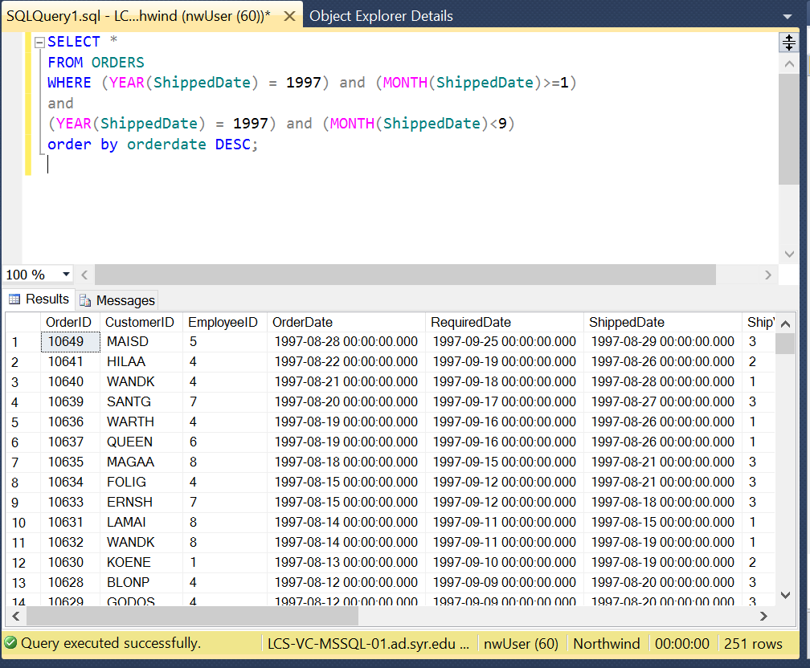

1. Select all data from the Orders table, ordered by OrderDate, newest date on top, for orders placed between July 1996 and January 1997.

SELECT *

FROM ORDERS

WHERE ((YEAR(ORDERDATE) = 1996) and (MONTH(ORDERDATE)>6))

OR

((YEAR(ORDERDATE) = 1997) and (MONTH(ORDERDATE)<2))

order by orderdate DESC;

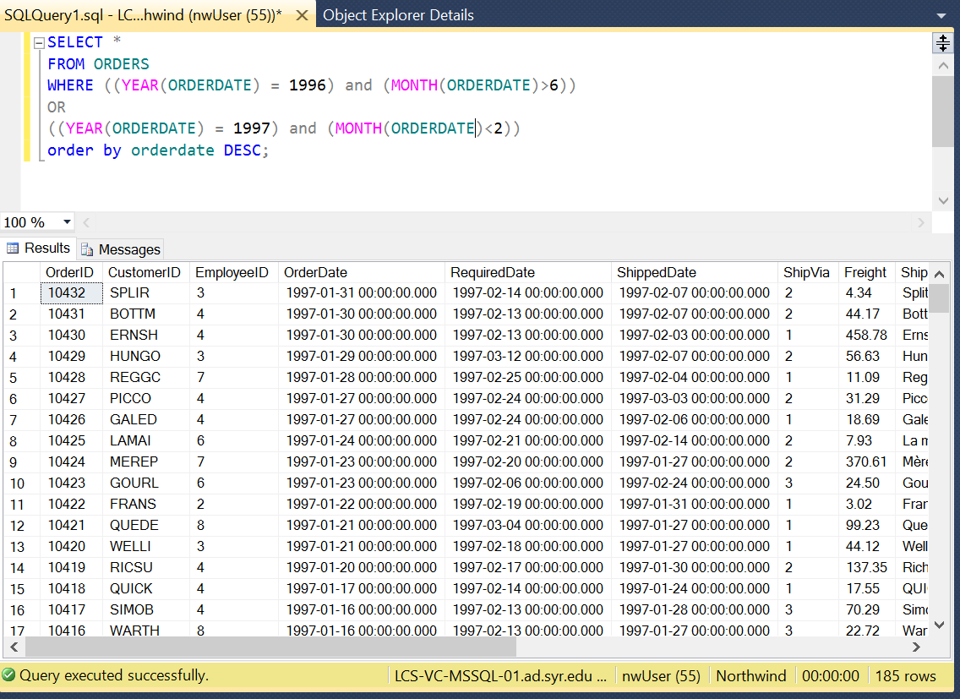

1. Select all data from the Orders table, for orders placed in January 1998.

SELECT *

FROM ORDERS

WHERE ((YEAR(ORDERDATE) = 1998) and (MONTH(ORDERDATE)=1));

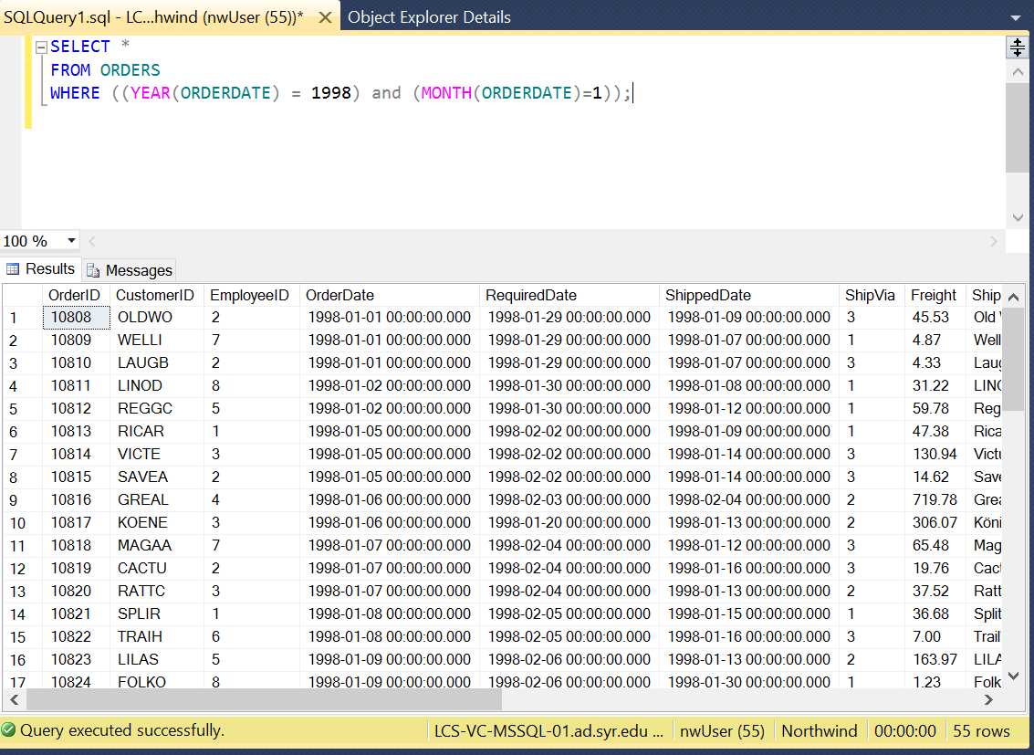

1. Select count of Orders shipped in 1996, 1997 and 1998. (one query containing all values) -> 2 columns (count and year), 3 rows (1 row per year)

SAMPLE (and hence WRONG) result for Q4:

|  |  |
| --- | --- |
| **Year** | **Number Of Orders Shipped** |
| 1996 | 55 |
| 1997 | 101 |
| 1998 | 104 |

SELECT year(shippeddate) as [Year], COUNT(*) AS [Number Of Orders Shipped]

from orders

group by year(shippeddate)

having (year(shippeddate)>=1996) and (year(shippeddate)<=1998)

order by year(shippeddate);

